Timesheet Portal Approver Guide
This guide describes how Timesheet Portal can be used to review timesheets. It is intended for line managers who use Timesheet Portal for submitting or approving timesheets, and not for administrators. Administrators should consult the online help available in the administration section of Timesheet Portal.
Approve / Review Timesheets
Depending on your account’s configured modules, you may either be automatically directed to a dashboard page or directly to the page where you can approve timesheets. If you are redirected to the dashboard page, you can click on Approve Timesheets in the Timesheets section to view timesheets available for approving.

If there are timesheets requiring approval, you will see a screen similar to the following screenshot:

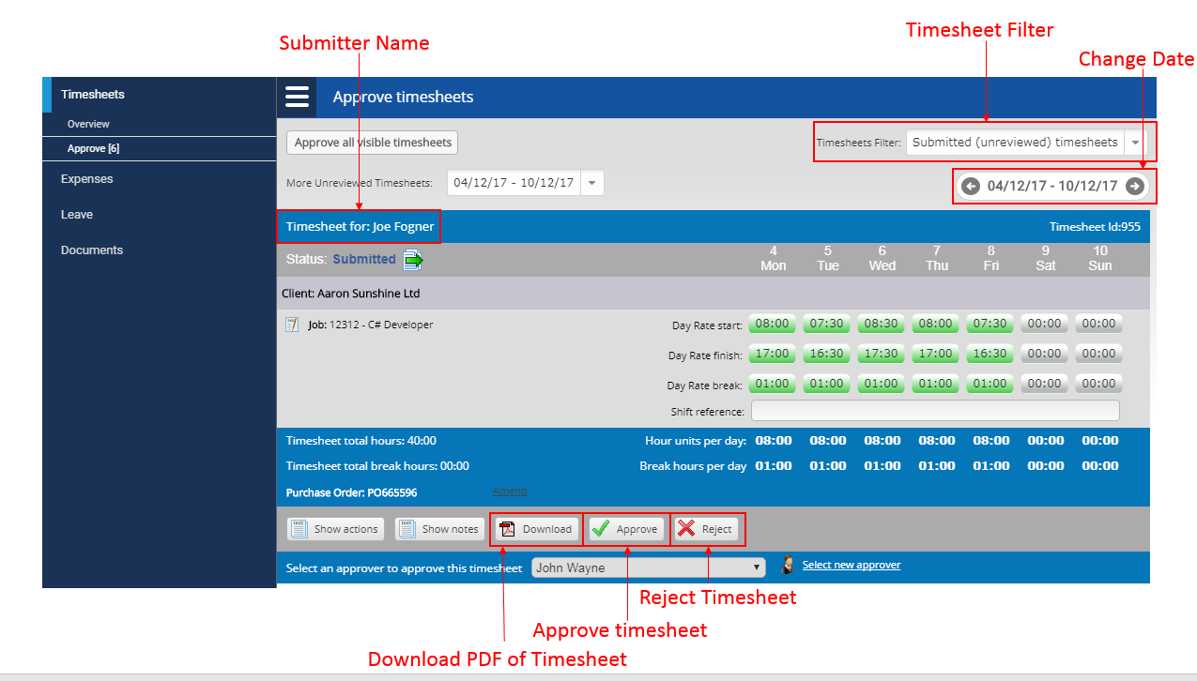

To move between different weeks, use the grey navigation arrows above the timesheet. You cannot see timesheets for multiple weeks at once; you must move between different weeks to view other timesheets. For faster navigation, you can use the calendar which can be found by clicking on the date above the current timesheet.
The hours for each timesheet are shown in the right hand area each timesheet. If you have more than one timesheet to approve (or reject) for the same week, they will be shown stacked on the same page. When approving, ensure the time is correct. If time is logged in hours and minutes, it will have a semi colon, e.g. 08:30 for 8 and a half hours. If time is logged in decimals, it will have a dot, e.g. 8.5 for 8 and a half hours.

Approve / reject timesheets
To approve a timesheet, click on the Approve button. To reject a timesheet, click on the Reject button. You will need to enter a reason for rejecting the timesheet, after which you can click Reject again. After rejection or approval, the contractor will receive an email to inform them of your action.

Once you have approved/rejected all the timesheets for a given week, you will automatically be shown the oldest timesheet week with un-reviewed timesheets. Check the date in the white drop down box if you are unsure of which week you are viewing.

View timesheet notes / history
To view the timesheet notes, click on the Show Notes button in the buttons section at the bottom of the timesheet. This will display any notes added to the timesheet.

To view the history of the timesheets, (e.g. time of submission), click the Show Actions button in the buttons section at the bottom of the timesheet.

Approve multiple timesheets
To approve multiple timesheets at once, tick the checkbox on the left of each timesheet (shown as Multiple approve checkbox in the screenshot), and then click on Approve Selected Timesheets at the bottom of the timesheets list.

View previously reviewed timesheets
You can view all timesheets you have previously approved or rejected. To see these, change the timesheets filter on the top of the timesheet to Approved & Rejected Timesheets.

Timesheet Management
Timesheet Portal allows you view all timesheets for any Contractors who are assigned to one or more of the Jobs you are responsible for approving. To view the timesheets, click on the Timesheet Management button in the left hand menu.

The Timesheet Management screen will show you a list of timesheets for all contractors that have timesheets for jobs within your organisation:

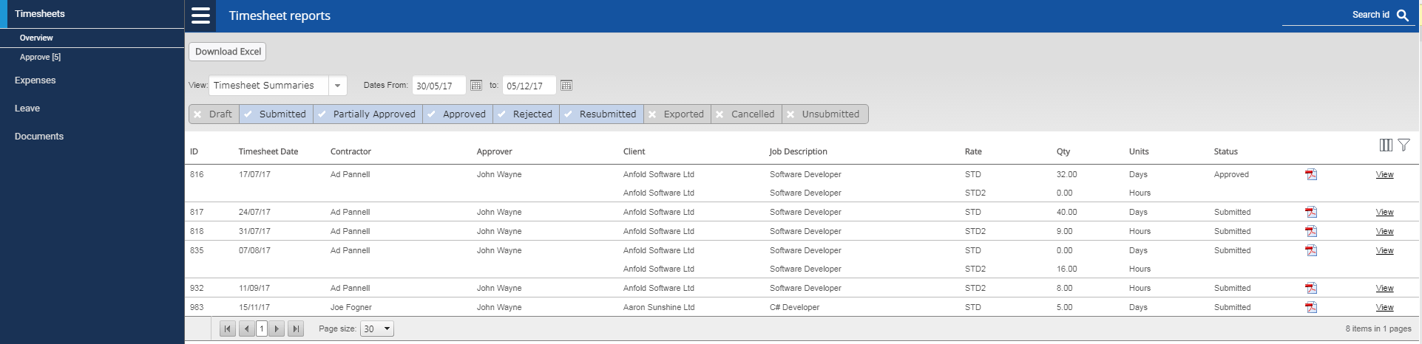
Timesheet Portal allows you to view all timesheets for an employeeterm who are assigned to one or more of the jobs you are responsible for approving. To view the timesheets, click on Timesheet Management button in the left hand menu.
The timesheet management screen will show you a list of timesheets for all contractors that have jobs within your organisation. The date range boxes allow you to filter out timesheets by the timesheet week start date. The status filter boxes allow you to filter out timesheets according to their status, e.g. if you wanted to see only rejected timesheets, you would only select the Rejected status box.
To view an individual timesheet, click on the View button on the right of the timesheet. To return to the summaries page, click on the back arrow.
To create a downloadable PDF timesheet, similar to the on-screen version, click on the PDF icon on the right hand side of the page.

Daily Entries View
To see the individual entries for a timesheet for each day in timesheet management, change the view dropdown on the top of the page to Daily Entries Per Timesheet. You can then download an Excel file directly from the timesheet management page by clicking on Download Excel in the top of your screen.
Weekly Totals View
To view weekly totals for each employeeterm and respective rate worked, change the Timesheets View dropdown to Timesheet Summaries

