Timesheet Portal Contractor User Guide
This guide describes how Timesheet Portal can be used to submit timesheets for your agency.
Submit Timesheets
If your agency has assigned you to a job, you will be directed to the timesheet screen, however if your system does not use the timesheet module you will be directed to the next active module.
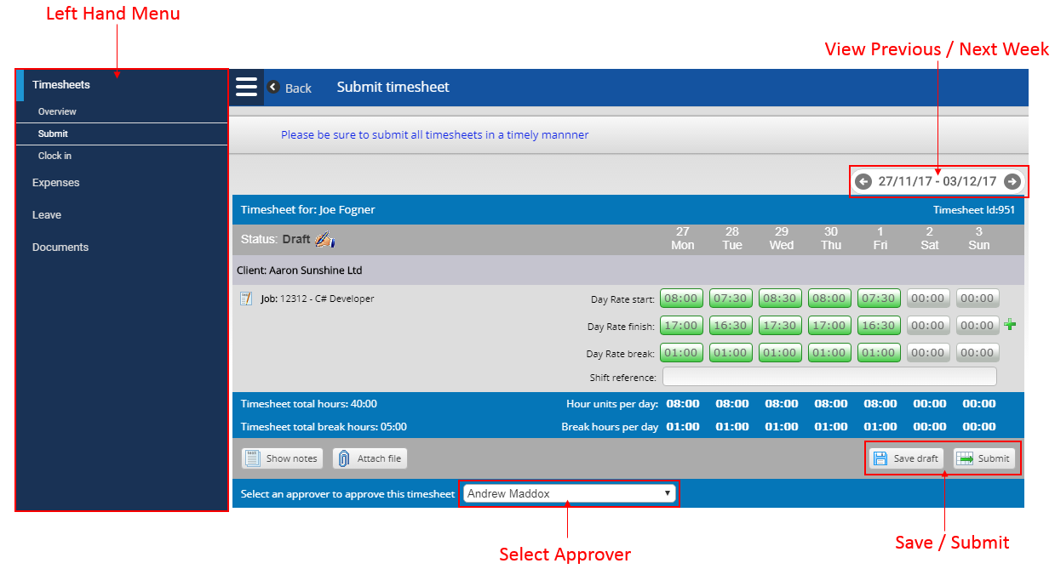
- General information
All sections in Timesheet Portal contain a left hand menu, allowing you navigate to different sections of the timesheet portal. If your screen is not wide enough to see the timesheet, you may want to hide the toolbar using the menu icon (Insert Icon) on the top right of the left hand menu.

Your timesheet for the current week will be shown in the main area. You do not need to create a new timesheet for each week. All you need to do is move to the week you are interested in, if you are assigned to a job for that week then you will see blank or previously created timesheets for that week. To move between different weeks, use the grey date navigation arrows.

To move between different weeks quickly, you can also use the calendar in the toolbar which is available by clicking on the date navigation panel in the top right of your timesheet page.

Hourly Time
The entry fields in the timesheet allow you to enter your hours worked. You should enter your time worked for each task in these fields. You can enter the time in the format HHMM, HH.MM or HH:MM. For example, to enter 8 hours and 30 minutes you could type in 0830, 08:30 or 830.

In the screenshot on the previous page, the start time, end time and total break time is being recorded. The total shown is the total hours between the start time and end time, minus the break time.

Note that some Jobs may require time to be entered in decimal format. You will know this is the case if the time shown in the fields has a decimal point rather than a colon. E.g. an entry for one and a half hours in decimal you type 1.50 whereas in HH:MM you type 01:30. To test if you are using HH:MM or decimal, type in 01:61. In decimal, this will be converted to 01.61 and turn green, whereas in HH:MM this is not valid, so it will turn red when you move to the next field.

Daily Time
Some Jobs may be configured to use days as the time unit. You will see the time units on the left hand side of the entry fields, so you will know whether your time is entered in days or hours. Sometimes daily time will be seen as a drop-down list for which you choose a specific number rather than entering the value, as per the example below:

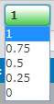

- Save & submit
You may save your timesheet before the submission date, so that you can enter your hours worked as you go. After saving your timesheet, your hours entered will be reloaded when you next log in. To save your timesheet, click on the Save Draft icon, located next to the submit button on the bottom right of the timesheet form.
To submit your timesheet, click the submit button on the bottom of the timesheet form. If you have been assigned multiple approvers, you can select the one for which you want to approve your timesheet using the drop-down list at the bottom of the timesheet. Once you submit your timesheet, you will not be able to make any changes to it unless your agency has enabled a feature which will allow you to edit and resubmit it again if it hasn’t yet been approved. An email will automatically be sent to your approver when you submit your timesheet, and you will receive an email when the timesheet is approved or rejected.

Rejected timesheets
If your timesheet is rejected by your approver, you will receive an email from Timesheet Portal (and a text message as well, if this has been enabled by your agency). Your timesheet will also have the Rejected status icon and a message on top of the page to state why it was rejected.

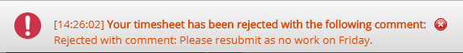

To resubmit a rejected timesheet, make your amends as if you were submitting it the first time, and click on the Submit button.

Add a daily note
To add notes relating to a specific day, click on time entry field for the day. If your screen is large enough, a small box will appear on the right hand side of the window, allowing you to enter your notes. If you are using a smaller display, the notes box may appear next to the time entry field. You can enter your note by simply typing any non-numeric character whilst on the time entry field, or by clicking in the notes box and entering your note there.

Once you have entered a note for a specific time entry, you will see a small yellow square in the top-right corner of the time entry field. You can edit your note by clicking back on the time entry field and editing it in the notes box. Alternatively, you can click on Show Notes at the bottom of the timesheet. This will show all your notes created within the timesheet itself.

To delete a note, click on the time entry field which contains the note, or click on the note text in the notes table if you have previously clicked on Show Notes. To delete the note, clear the text in the notes box and click out of the box to save.

Download Timesheets
Once your timesheet has been submitted, you may download it for printing. You will need Adobe Acrobat reader installed to view the downloaded timesheet, which is produced in the PDF format. To download a timesheet, open up the timesheet by navigating to the timesheet week, or click on View from the timesheet overview (see next section). You will see a Download Timesheet icon at the bottom of the timesheet, as illustrated in the screenshot below

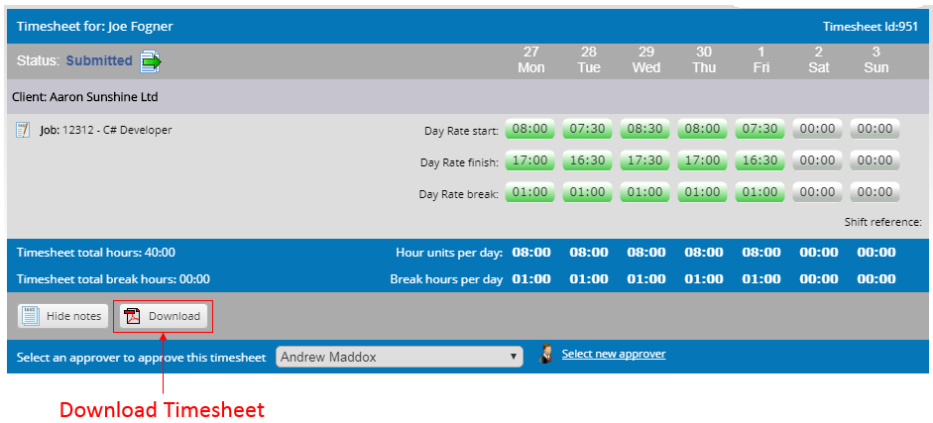
View Past Timesheets
To view your past timesheets, click on Overview in the left hand navigation. This will present a table listing all your current and previous timesheets, showing basic information about the timesheet, such as its current status (submitted/approved/rejected). You can adjust the dates and apply filters on the status. If you see a status of Exported, this usually means it has been exported into your agency’s payroll / billing system. This can only happen if a timesheet is already approved.

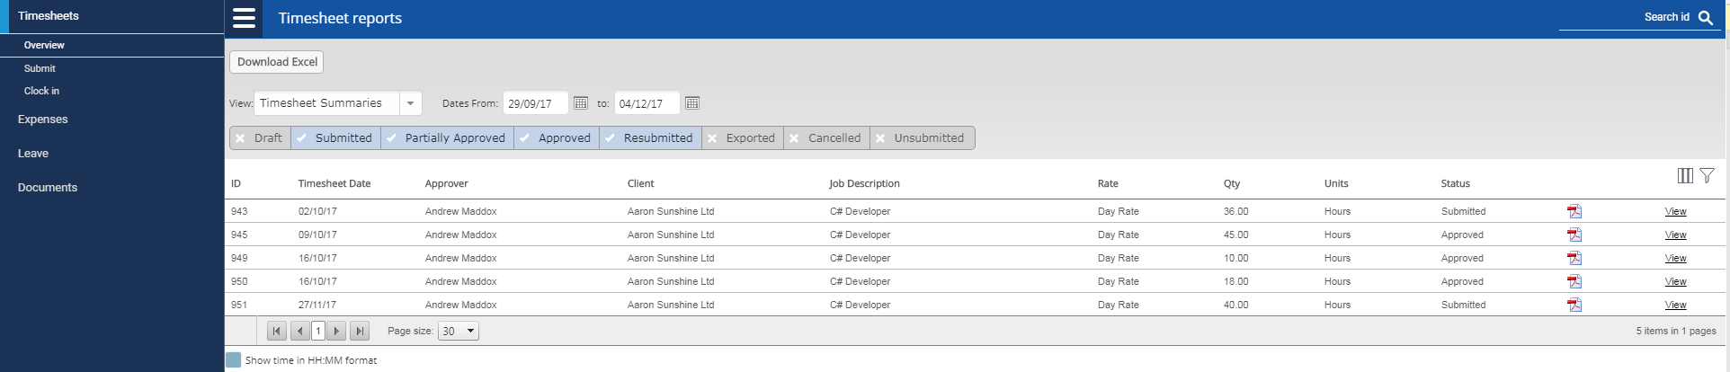

To view the full details of a timesheet, click View on the right hand side to open it, or click on the PDF icon to download it as a PDF. You can also download the list of timesheets as an Excel file by clicking on Download Excel at the top of the page.

